Student Patent Novelty Check – Progress Summary & Next Steps
Overview
This project aims to build a student-friendly patent novelty checking tool that allows users to describe an idea in natural language and quickly see similar existing patents, along with clear explanations of why those patents are relevant. The focus so far has been on creating a working end-to-end prototype that demonstrates feasibility, usability, and integration with real patent data.
At this stage, the system supports structured idea input, CPC classification, similarity-based patent retrieval, and explainable results — all through a simple web interface.

What Has Been Accomplished So Far
1. End-to-End System Architecture
The application has been implemented as a full-stack system with a clear separation of concerns:
- A backend API that handles idea processing, CPC mapping, patent search, and logging
- A frontend web application that guides users through idea submission and displays results in a student-friendly way
- A lightweight database layer for tracking searches and system usage
This structure makes the system easy to extend, debug, and scale in future phases.

Backend Implementation
The backend is built using FastAPI and serves as the core logic layer of the system.
Key Responsibilities of the Backend
- Accept structured idea input from the frontend
- Map ideas to relevant CPC (Cooperative Patent Classification) areas
- Query real patent data using the USPTO PatentsView PatentSearch API
- Generate human-readable “why this is similar” explanations
- Log all searches for analysis and evaluation
Live Patent Data Integration
A major milestone was successfully integrating the USPTO PatentsView PatentSearch API.
The backend now:
- Authenticates securely using an API key stored as an environment variable
- Sends structured queries based on CPC areas and idea context
- Normalizes patent results into a consistent internal format
- Falls back to mock data gracefully if the API is unavailable
This ensures that demos work reliably while still showcasing live data when available.
Explainability Layer
Rather than returning raw similarity scores alone, the backend generates contextual explanations, such as:
- Overlapping technologies (e.g., AI/ML, IoT, Mobile)
- Similar automation or data-analysis workflows
- Shared application domains
- CPC classification alignment
This design choice keeps the system accessible to non-technical users, especially students unfamiliar with patent language.

Frontend Implementation
The frontend is built using Next.js (React) and focuses heavily on usability and clarity.
User Experience Design
The interface walks users through the idea submission process using plain language prompts, including:
- The problem being solved
- What the idea does (via checkboxes)
- Domain selection
- Key technologies involved
- Optional novelty description
Once submitted, results are displayed as clean, readable cards showing:
- Patent title, year, and assignee
- CPC classification
- Similarity score
- A clear “Why this is similar” section
This mirrors how a student would naturally think about novelty, rather than forcing them to understand patent jargon upfront.
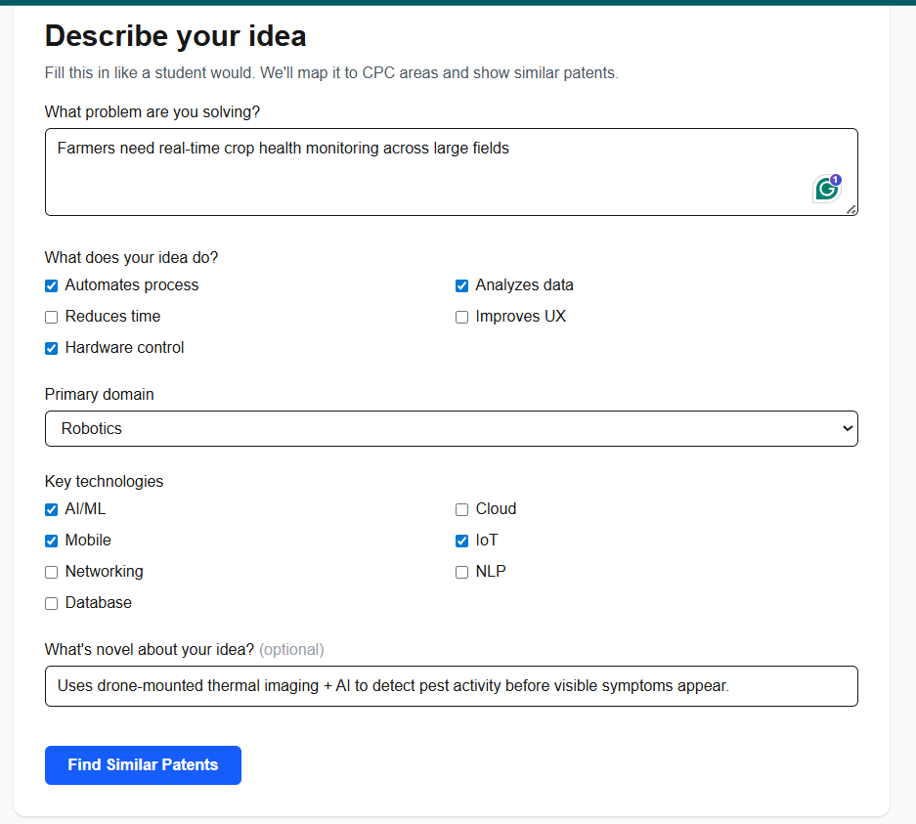

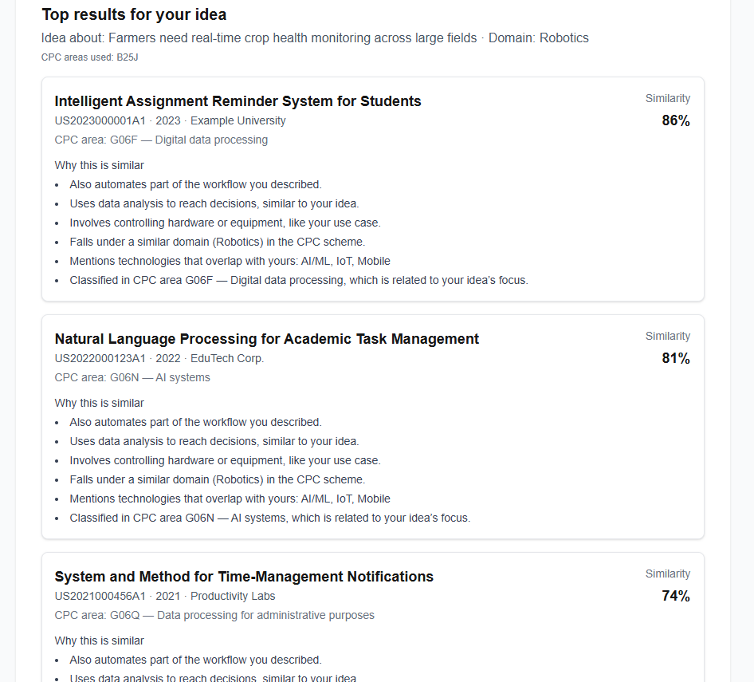
Database & Logging
A lightweight SQLite database is used to log searches.
What Is Being Logged
Each search captures:
- Timestamp
- Problem description
- Domain and technologies selected
- CPC areas used
- Number of results returned
- Whether the search used live or fallback data
This provides a foundation for:
- Usage analysis
- Improving CPC mapping rules
- Evaluating how students interact with the tool
- Supporting future research or coursework analysis
The database can be easily inspected using tools like DB Browser for SQLite.
Tools & Technologies Used
Backend
- Python
- FastAPI
- Uvicorn
- USPTO PatentsView PatentSearch API
- Requests (HTTP client)
Frontend
- Next.js (React)
- TypeScript
- Tailwind CSS
Database
- SQLite
Development & Debugging
- VS Code
- Swagger UI (FastAPI docs)
- DB Browser for SQLite
- Command Line / PowerShell

Current State of the System
At present, the system:
- Runs locally end-to-end
- Successfully connects to a live USPTO patent database
- Returns structured, explainable patent similarity results
- Supports realistic demo scenarios for academic use
This represents a functional pilot-ready prototype, not just a mock or concept demo.
Next Phase: What Comes Next
The next phase focuses on depth, scalability, and refinement, rather than basic functionality.
Planned Enhancements
- Improved similarity scoring using embeddings or semantic models instead of rule-based heuristics
- Richer explanations, including highlighted claim overlaps or keyword matches
- User accounts or sessions to track individual student usage
- Caching and rate-limit handling for large-scale demos
- Deployment to a hosted environment for broader access
Potential Cost Considerations
- Cloud hosting (AWS / Azure / Vercel / Railway)
- Higher-volume API usage if scaled beyond demos
- Optional use of paid embedding or LLM APIs for deeper semantic comparison

Conclusion
So far, this project has moved from concept to a working, integrated system that demonstrates how students can meaningfully explore patent novelty without needing deep legal or technical expertise. The current prototype validates both the technical feasibility and user experience approach, setting a strong foundation for future expansion and academic or institutional use.

